Documentation Microservice: Get

Goal: Display our Database on a HTML page

The microservice language is java.

First Car.java:

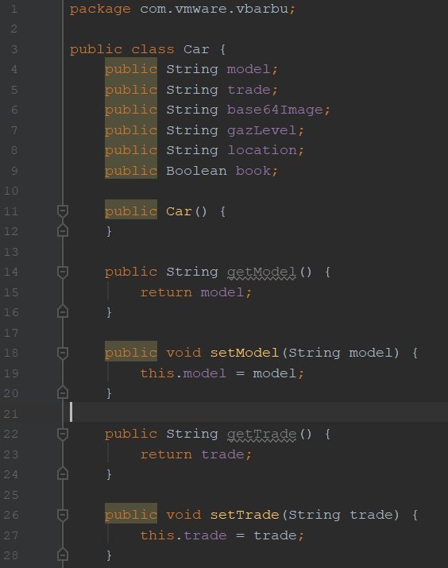

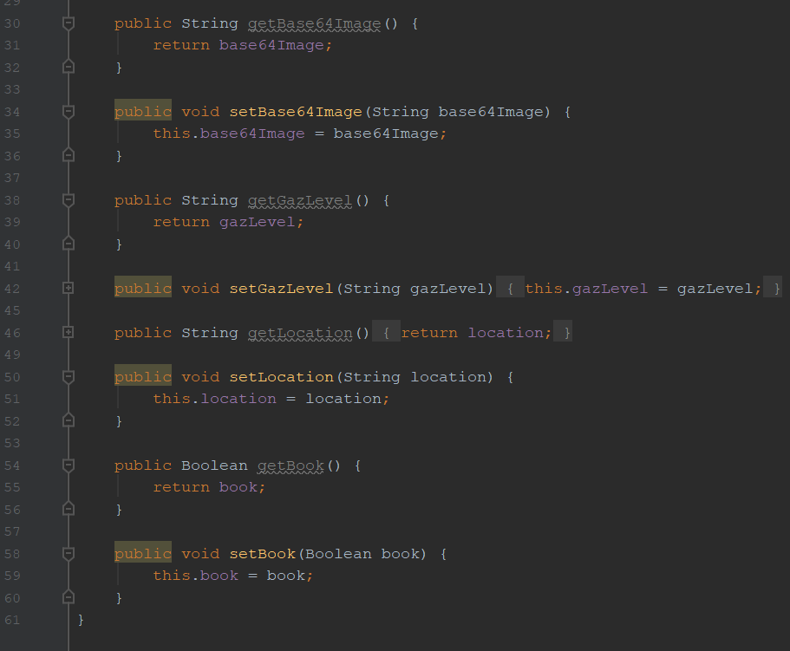

Here we declare our Getters and Setters to work with them. We can see that each variable is string type except the book one, is a Boolean type.

It respects the type in our database.

Car.Dao file:

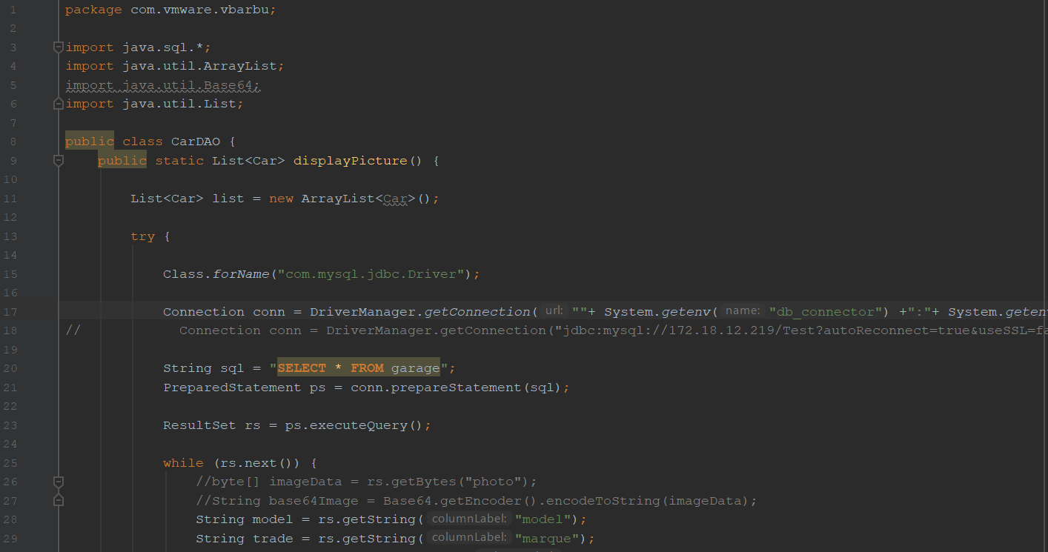

Line 17: Connection conn = DriverManager.*getConnection*(""+ System.*getenv*("db_connector") +":"+ System.*getenv*("db_type") +"://"+ System.*getenv*("db_ip") +"/"+ System.*getenv*("db_name") +"?autoReconnect=true&useSSL=false", ""+ System.*getenv*("db_username") +"", ""+ System.*getenv*("db_password") +"");

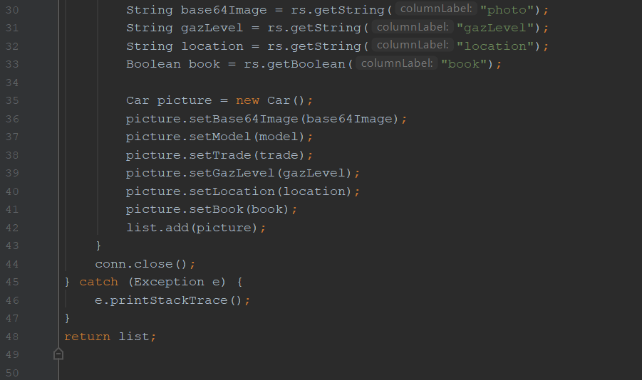

Here in this file,



The conn variable able to make the connection to our database with a jdbc driver here:



Then, we execute a query that allow to us to see every element in our database.

And we stock the result in a variable name: rs ->



Then, we want to attribute each result to each variable, that’s why, we use a while to go through our result variable.

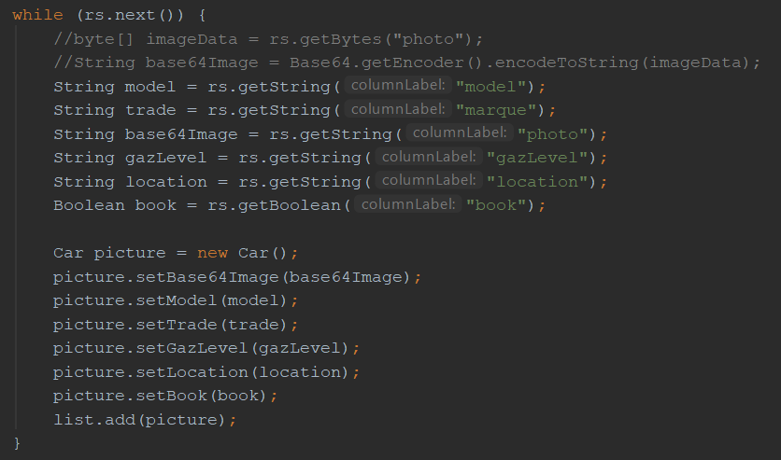

As we can see, we attribute each variable a result that correspond to the element in our database.

ForwardController.java:

This file allows to us to set our URL = “/getcar”

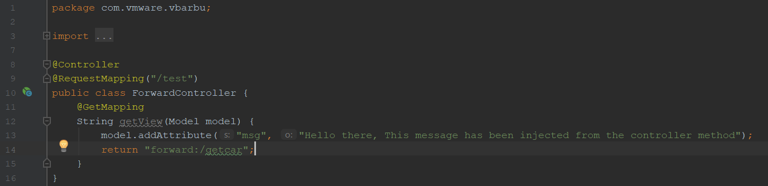

GetAllCarServlet.java:

This file allows to us to create the webservlet to our tomcat server and set the index.jsp that will be the main style page.

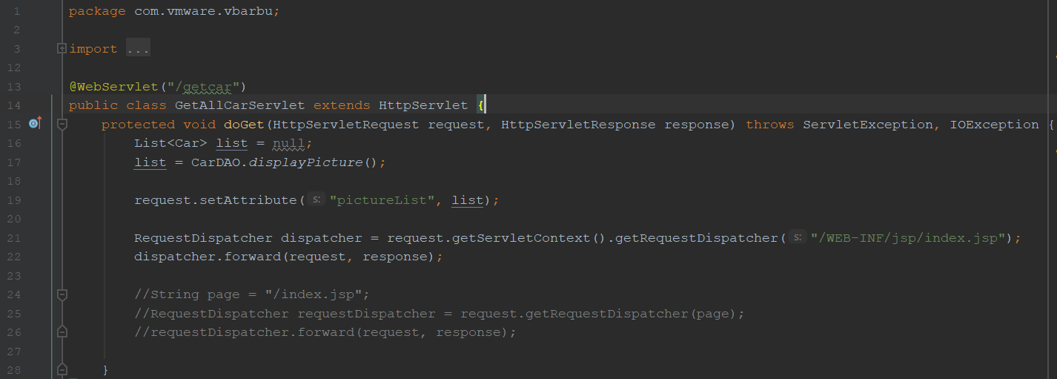



Here, we chose our list that we want to display: pictureList. It will allow to us to display the element on by on our HTML page.



We declare our index.jsp, like an index.html, it will display our main page.

VbarbuApplication.java:

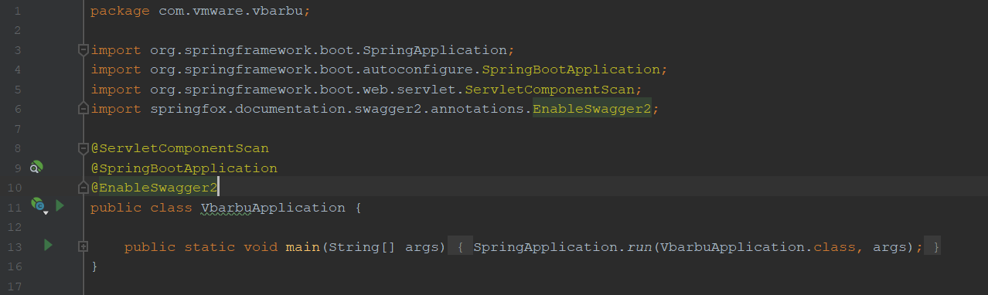

Here, it a simple method to run our code and run the tomcat Server through the Spring Application.

Index.jsp:

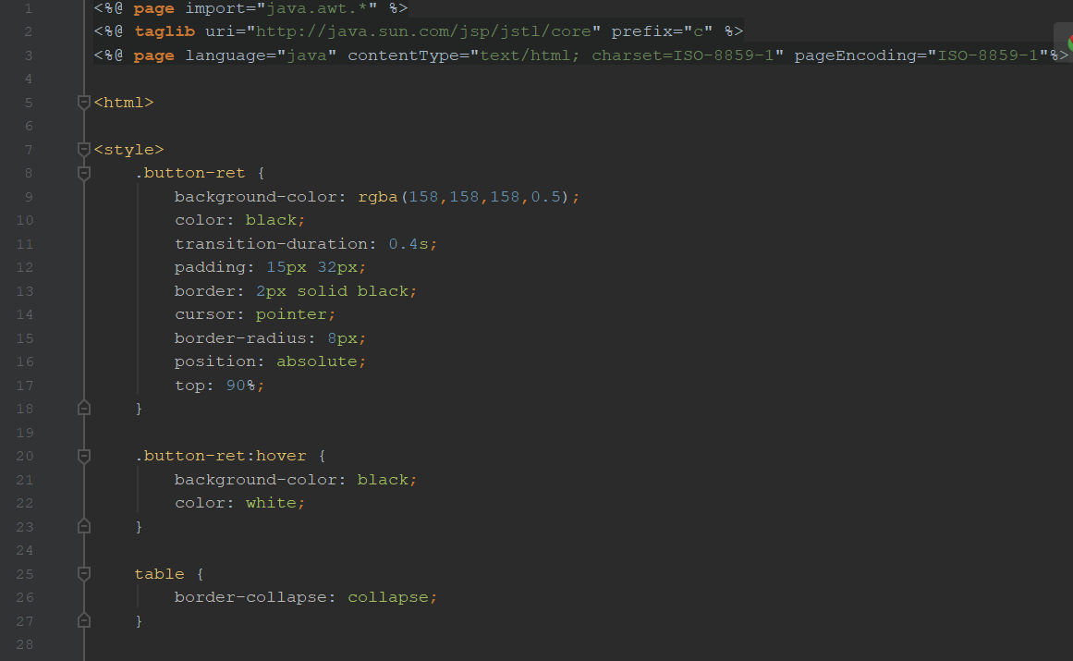

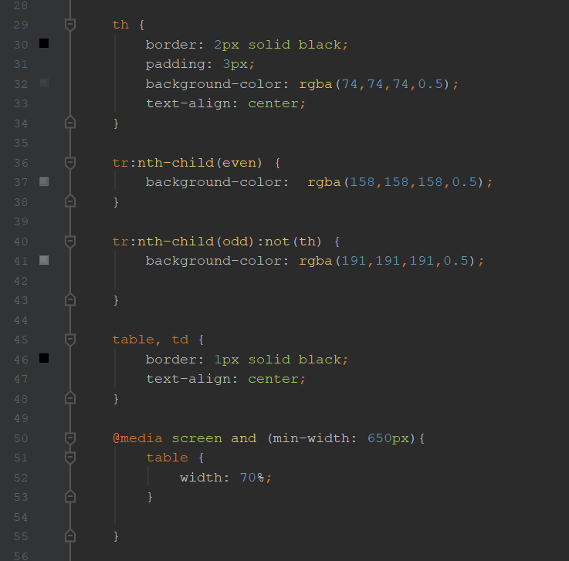

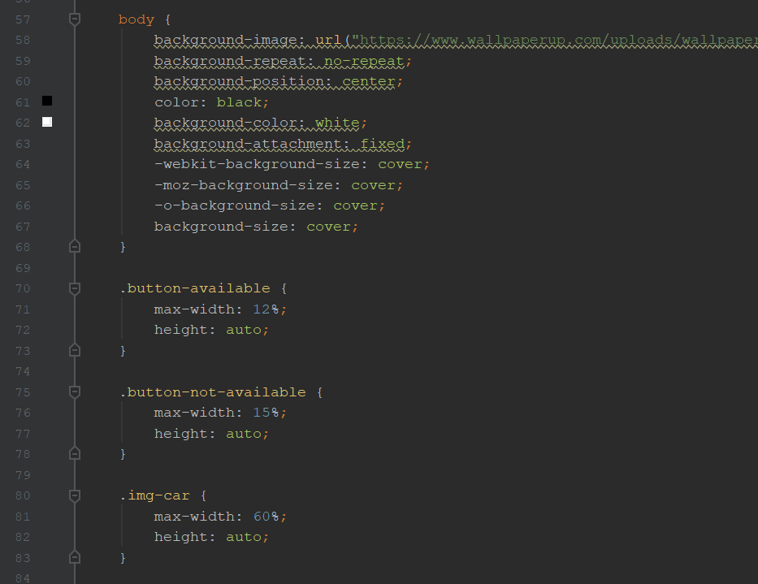

Line 58: background-image: url("https://www.wallpaperup.com/uploads/wallpapers/2013/08/19/135949/00297a2528269ffcd01955cb6acb0a12.jpg");

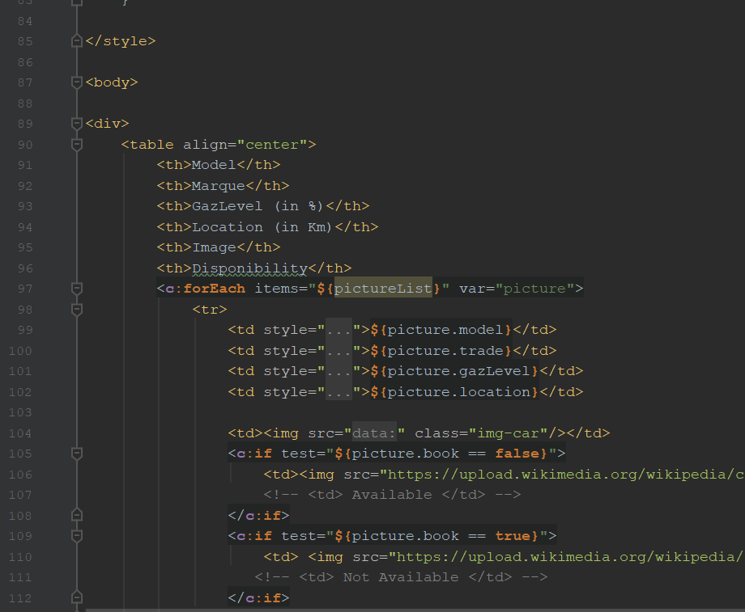

Line 106: <td><img src="https://upload.wikimedia.org/wikipedia/commons/5/58/Disponible.png" class="button-available"></td>

Line 110: <td> <img src="https://upload.wikimedia.org/wikipedia/commons/thumb/1/16/Deletion_icon.svg/600px-Deletion_icon.svg.png" class="button-not-available"> </td>

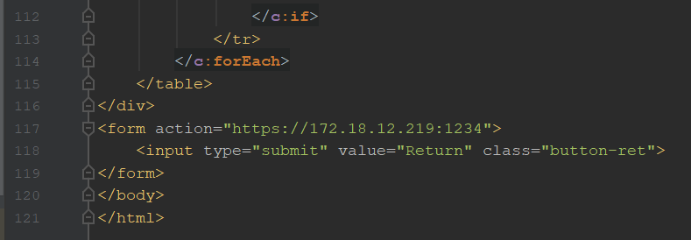

Application.properties file:

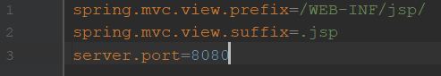

This file allows to us to set our server port and declare also our jsp file and the direction.

Pom.xml file:

Set our dependencies.

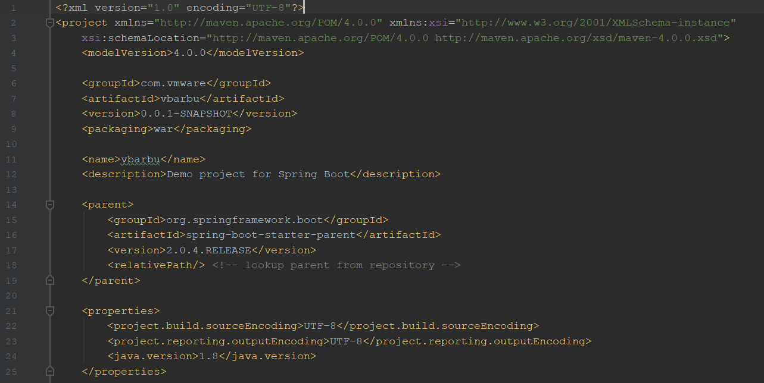

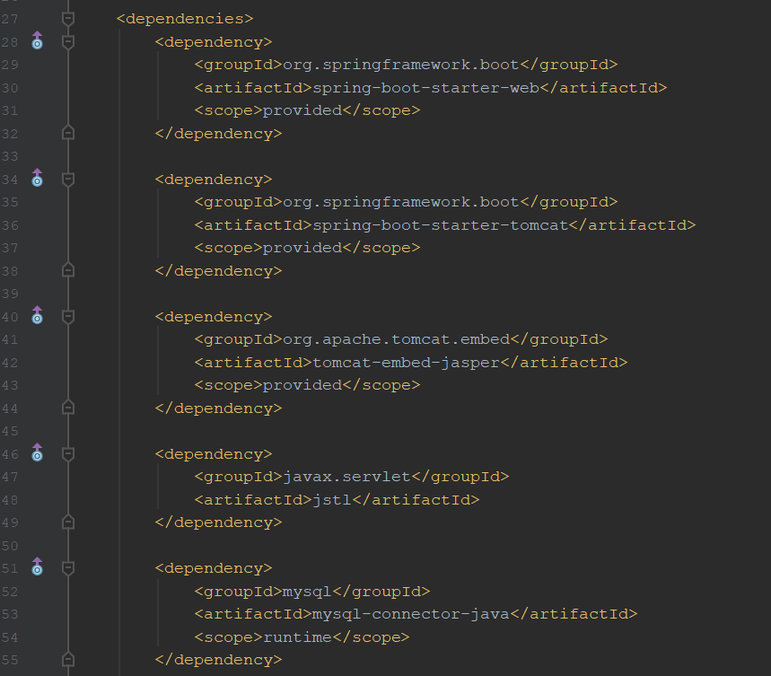

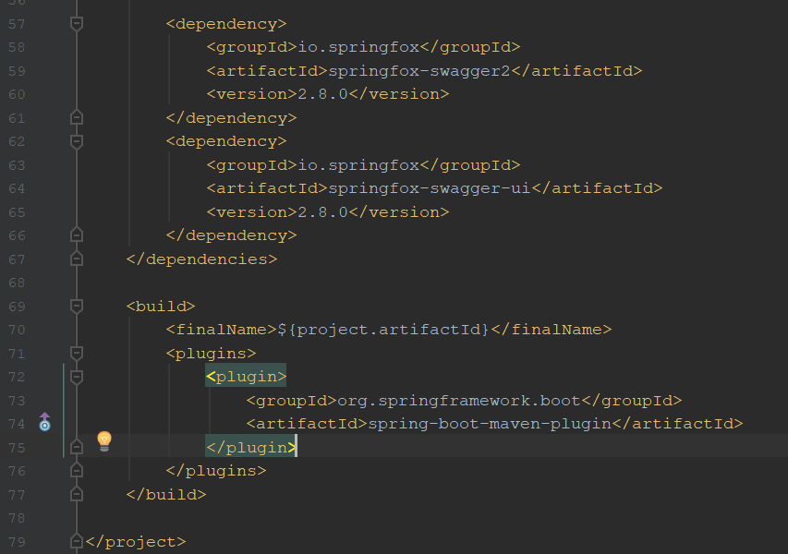

The dockerfile, to set our env variable:

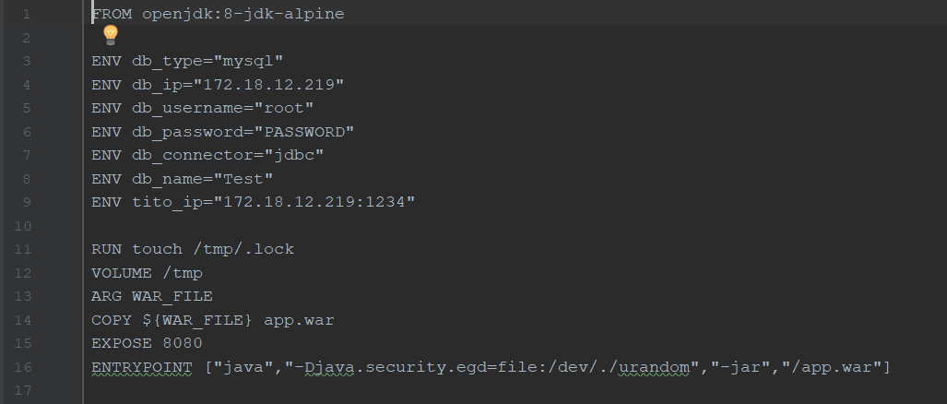

Then, we got our microservice get that display our database on HTML page.

Ip: 172.18.12.219:1111